CRIDEX

The following sample has been obtained from here -
Memory Samples · volatilityfoundation/volatility Wiki · GitHub

The first step is to determine a profile for the memory dump. This can be done as shown below:-

./volatility -f /home/kali/Desktop/cridex.vmem imageinfo

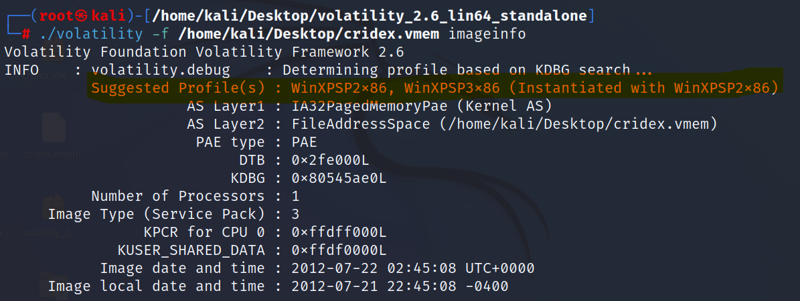
Process list for the memory image:-

./volatility -f /home/kali/Desktop/cridex.vmem --profile=WinXPSP2x86 pslist

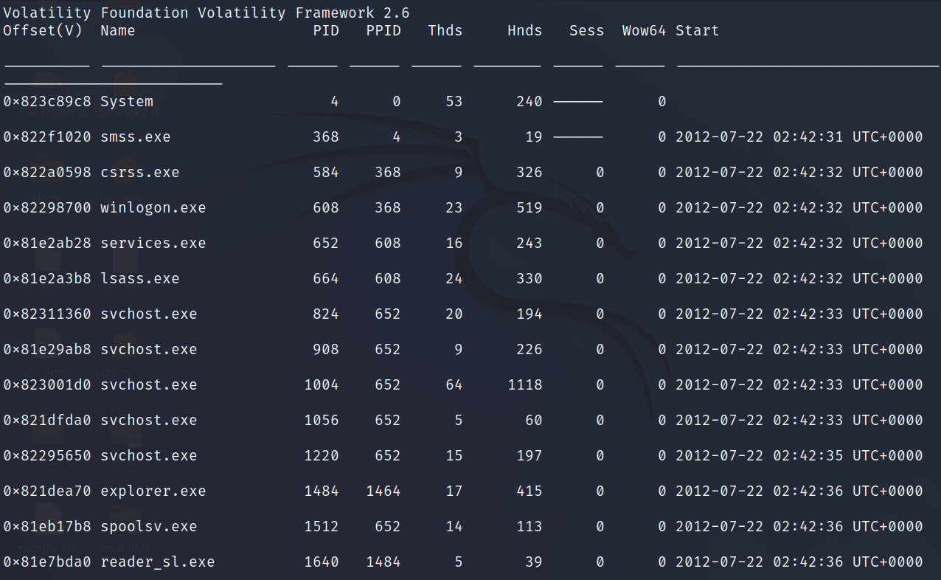

Process and their associated PID’s we can now move onto the process tree of the same.

./volatility -f /home/kali/Desktop/cridex.vmem --profile=WinXPSP2x86 pstree

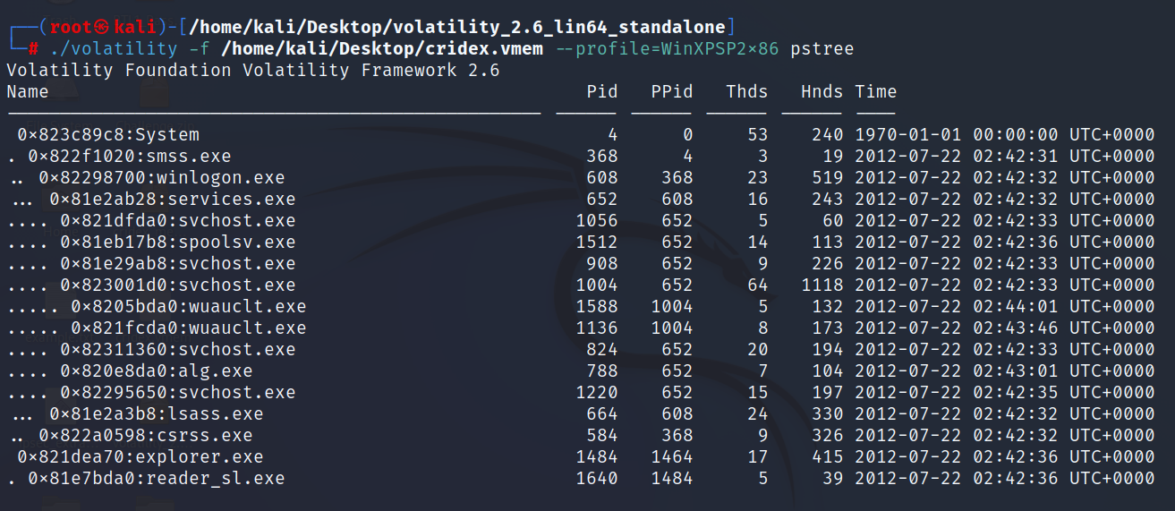
We can see the process’s cascaded within each other.
We can see two principle process’s system (PID – 4) and explorer.exe (PID – 1484).
We can also see explorer.exe has a child process called ‘reader_sl.exe’ (PID – 1640).

Next, we can check for hidden process’s.

./volatility -f /home/kali/Desktop/cridex.vmem --profile=WinXPSP2x86 psxview
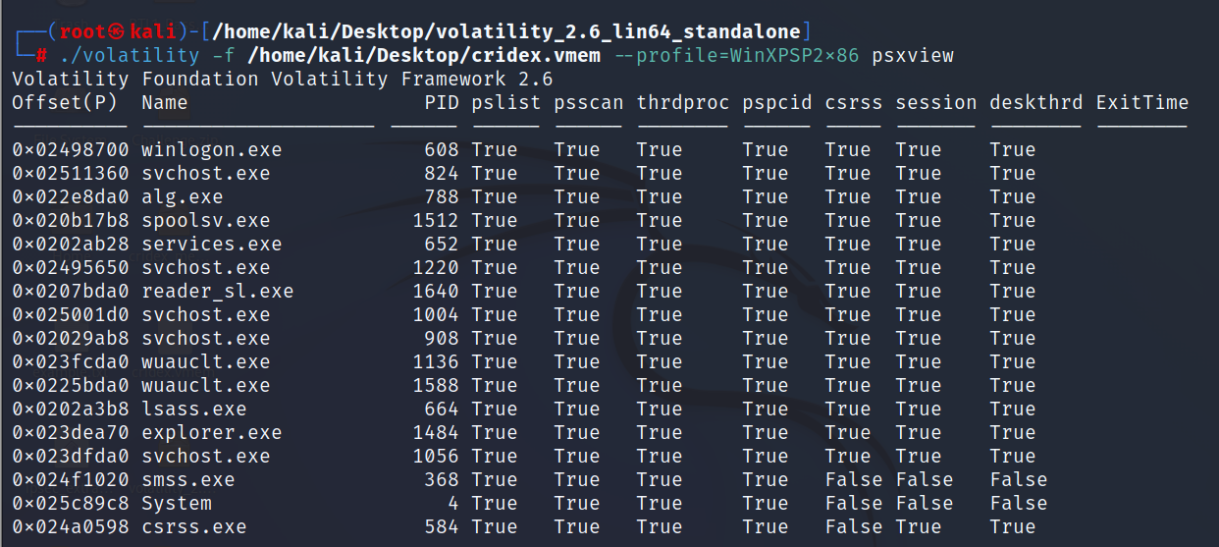
As relevant from the above there are no hidden process’s. As we can see (pslist and psscan) is true for all process’s.

Network connections

Outbound TCP connections

TCP connections can be listed with the help of connscan.

./volatility -f /home/kali/Desktop/cridex.vmem --profile=WinXPSP2x86 connscan

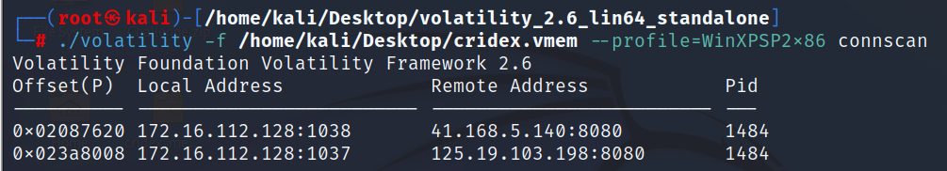
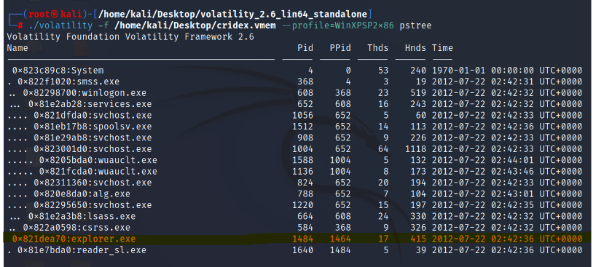
As we can see, PID 1484 has two TCP connections.

Let’s check open sockets.

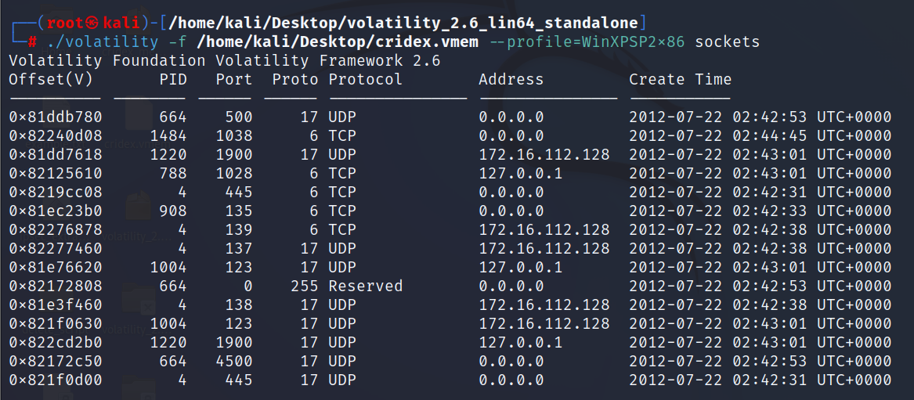
We can see one TCP socket is open.
The port number of the following 1038 and the PID is 1484 which is internet explorer. This indicates it’s open to receive connections.

Offset(P) Local Address Remote Address Pid
---------- ------------------------- ------------------------- ---
0x02087620 172.16.112.128:1038 41.168.5.140:8080 1484

Let’s dig a little deeper into the process 1484 and it’s subprocess ‘reader_sl.exe’ (PID – 1640).

Location of process’s can be found out with the help of command line plugin.

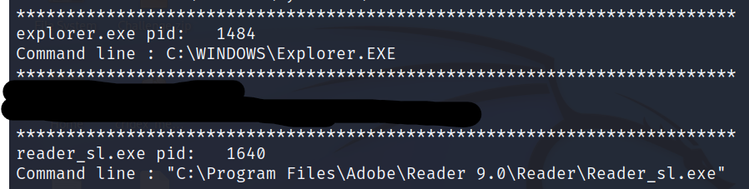

We can see the process (1640) is from Adobe reader which open up in explorer.exe. There should be no significant reason for keeping open connections to remote hosts.

A dump of this program can be taken and analysed further in Ghidra.

The dump can be taken in the following manner.

./volatility -f /home/kali/Desktop/cridex.vmem --profile=WinXPSP2x86 procdump -p 1640 --dump-dir .

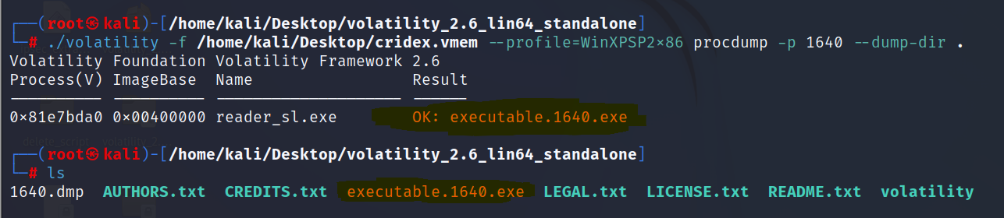

Let’s take a memory dump to see strings for clues we can use the remote IP address -

./volatility -f /home/kali/Desktop/cridex.vmem --profile=WinXPSP2x86 memdump -p 1640 --dump-dir .
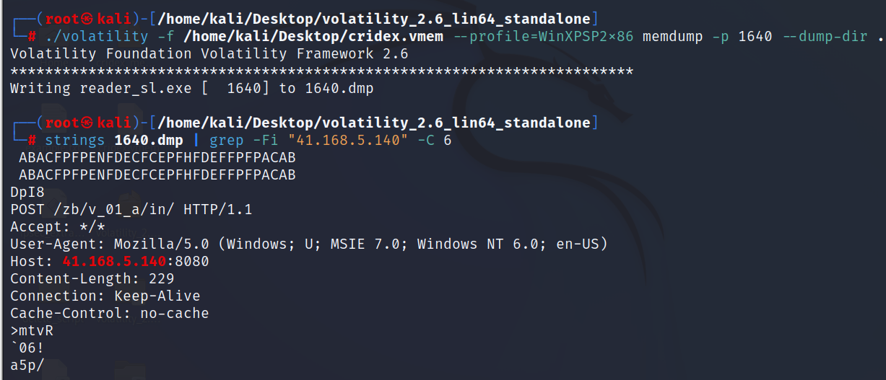
We can see post requests to the foreign ip address.

We can upload the sample executable sample to virus total or reverse engineer with ghidra.

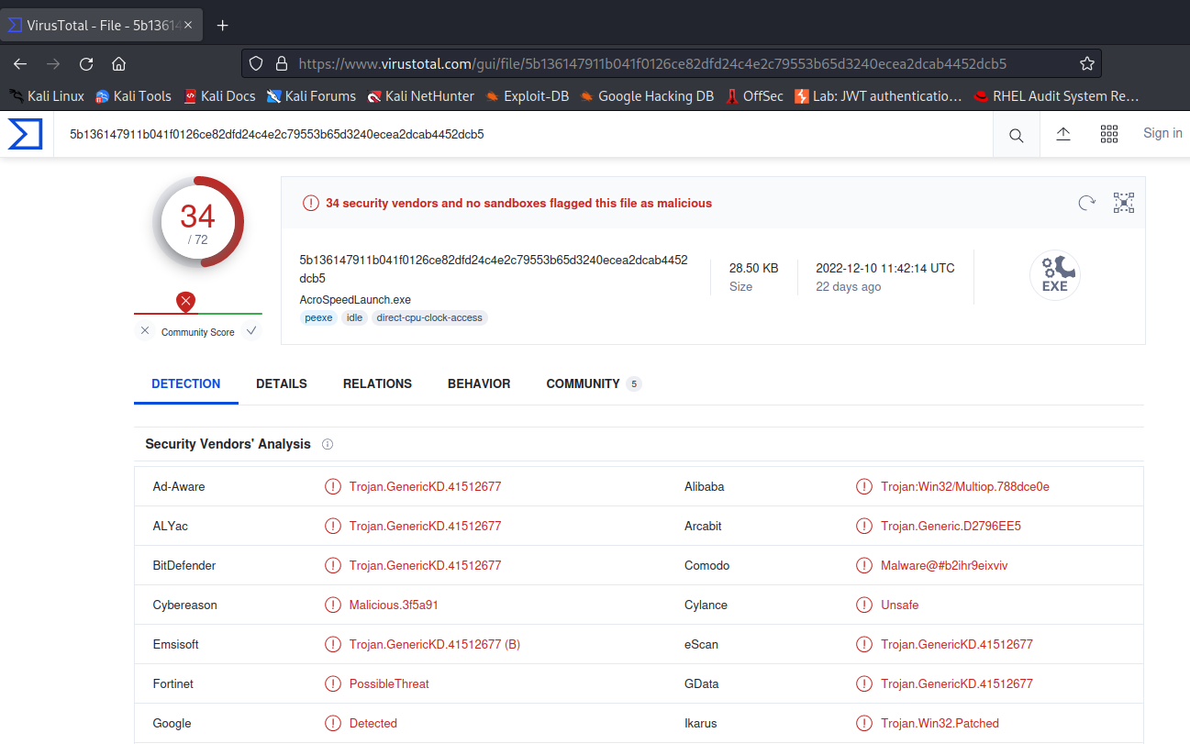
We can see the executable is malicious.

